Selenium Tutorial

Selenium tutorial provides basic and advanced concepts of Selenium. Our Selenium tutorial is designed for beginners and professionals.
Selenium is one of the most widely used open source Web UI (User Interface) automation testing suite.
Our Selenium tutorial includes all topics of Selenium such as Features, Selenium vs QTP, Selenium Tool Suits, Selenium IDE, Selenium IDE Locating Strategies, Selenium WebDriver, WebDriver Features, WebDriver vs RC, WebDriver Installation, etc.

What is Selenium
Selenium is one of the most widely used open source Web UI (User Interface) automation testing suite.It was originally developed by Jason Huggins in 2004 as an internal tool at Thought Works. Selenium supports automation across different browsers, platforms and programming languages.
PauseNext
Unmute
Current TimeÂ 0:21
/
DurationÂ 18:10
Loaded: 6.97%
Â
Fullscreen
Selenium can be easily deployed on platforms such as Windows, Linux, Solaris and Macintosh. Moreover, it supports OS (Operating System) for mobile applications like iOS, windows mobile and android.
Selenium supports a variety of programming languages through the use of drivers specific to each language.Languages supported by Selenium include C#, Java, Perl, PHP, Python and Ruby.Currently, Selenium Web driver is most popular with Java and C#. Selenium test scripts can be coded in any of the supported programming languages and can be run directly in most modern web browsers. Browsers supported by Selenium include Internet Explorer, Mozilla Firefox, Google Chrome and Safari.
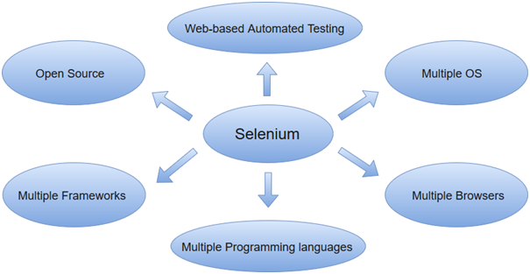
Selenium can be used to automate functional tests and can be integrated with automation test tools such as Maven, Jenkins, & Docker to achieve continuous testing. It can also be integrated with tools such as TestNG, & JUnit for managing test cases and generating reports.

Selenium Index

Selenium
- Selenium Tutorial
- Selenium Basic Terminology
- Selenium Features
- Selenium Limitations
- Selenium vs QTP
- Selenium Tool Suite
Selenium IDE
- Selenium IDE
- IDE-Installation
- IDE-Features
- IDE-First Test Case
- IDE-Login Test
- IDE-Commands
- IDE-Creating Test Cases Manually
- IDE- Locating Strategies
  - IDE- Locating by Identifier
  - IDE- Locating by ID Element
  - IDE- Locating by Name
  - IDE- Locating by XPath
  - IDE- Locating by CSS
    - Locating by ID
    - Locating by Class
    - Locating by Attribute
    - Locating by ID/Class & Attribute
    - Locating by Sub-string
    - Locating by inner text
  - IDE- Locating by DOM
Selenium WebDriver Tutorial
- Selenium WebDriver
- WebDriver-Architecture
- WebDriver-Features
- WebDriver Vs RC
- WebDriver-Installation
- First Test Case
- WebDriver Commands
- Running Test on Chrome
- Running Test on Firefox
- Running Test on IE
- Running Test on Safari
- Locating Strategies
  - Locating Strategies By ID
  - Locating Strategies By Name
  - Locating Strategies By Class Name
  - Locating Strategies By Tag Name
  - Locating Strategies By Link Text
  - Locating Strategies By Partial Link Text
  - Locating Strategies By CSS
    - Tag and ID
    - Tag and Class
    - Tag and Attribute
    - Tag, Class and Attribute
    - Sub-String Matches
  - Locating Strategies By XPath
    - Using Single Slash
    - Using Double Slash
    - Using Single Attribute
    - Using Multiple Attribute
    - Using AND
    - Using OR
    - Using contains()
    - Using starts_with()
    - Using text()
    - Using last()
- Handling Drop-Downs
- WebDriver-Drag and Drop
- WebDriver-Handling Alerts
- Scrolling a Web Page
- WebDriver - Browser Commands
- WebDriver - Navigation Commands
- WebDriver - WebElement Commands
- Handling Radio Buttons
- Handling Checkbox
- Selenium Assertions
- Selenium Grid
Selenium Python Tutorial
- Selenium Python
Selenium C# Tutorial
- Selenium C#
TestNG with Selenium
- TestNG Tutorial
- TestNG Introduction
- TestNG Installation
- Features of TestNG
- Running Test Cases
- TestNG XML File
- Exclude/Include Test Cases
- Running Test Cases with Regex
- TestNG Groups
- TestNG Annotations
- 1) @BeforeSuite
- 2) @AfterSuite
- 3) @BeforeTest
- 4) @AfterTest
- 5) @BeforeClass
- 6) @AfterClass
- 7) @BeforeMethod
- 8) @AfterMethod
- 9) @BeforeGroups
- 10) @AfterGroups
- Annotation Attributes
- TestNG Parameters

Prerequisites
Before learning the concepts of Selenium, you should have a basic understanding of java or any other object-oriented programming language.
Languages supported by Selenium include C#, Java, Perl, PHP, Python and Ruby.Currently, Selenium Webdriver is most popular with Java and C#. So, if you know any of the languages then it won't be tough to understand the concepts of Selenium. In addition, you should have prior knowledge of software testing techniques like automation testing, functional testing, etc.

Audience
Our Selenium Tutorial is des
Mantis is a web-based bug tracking tool. Developed in PHP, it is used by many businesses as defect logging and tracking system. We will discuss some of its features:
- MantisBT is an open source tool. It is free of cost to use for all type of organization’s big, or small. It is released under GPL (General Public License). Mantis BT also has a paid version “MantisHub”. MantisBT provided as a Service is MantisHub.
- The MantisBT comes with different evaluation versions, ”Demo”, ”MantisHub”, “Mantis2Go” for the companies to use. The organizations can have a hands-on Demo version available on its official site. MantisHub is a SAAS product of MantisBT, Mantis2Go is out of box installation of MantisBT but it is not recommended for production use. Mantishub is used for quick, instant use of Mantis but it is a paid version.
- User Interface: The user interface offered by Mantis is very simple and easy to understand. It is hassle free and easy for collaboration between team and client.
- It is a web-based tool which runs on the browser. MantisBT supports all types of browsers like Chrome, Firefox, Safari, and IE45 and above.
- MantisBT is compatible with any platform which runs PHP. It will work on Linux, Windows, MacOS, and Solaris.
- Customization of pages is a key functionality of Mantis Bug Tracker. The administrator can add custom fields at the project level depending upon the project requirements. The administrator is also able to customize user roles, the user accesses at the project level.
- Multiple Project Support: Mantis supports multiple projects access as per user access level under a single login, projects can be further divided into sub projects ad categories. The projects are properly isolated from each other and are available to users according to access levels.
- Dashboard: A user account personalized view shows a summarized list of issues raised for all the projects assigned to that user, assigned by the user indicated with different colors. The issue detail page can be reached by clicking on the particular bug Id from the list page. Timeline feature allows viewing the happenings of the project.
- The search functionality offered by MantisBT allows users for basic search by entering text as well as advanced search by advanced filters.
- The user is able to export the bug list into the CSV file or Microsoft word file.

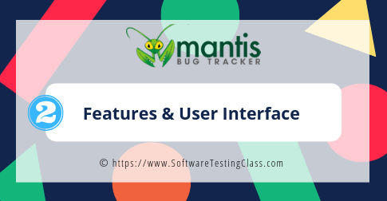
- Bug Reporting: The users are able to report issues by traditional methods of logging into the account and raising bugs. Another feature MantisBT supports is by sending email to the system or by custom form from the website.
- Access Level of Projects, Issues: The user will be able to control the access level of projects to either private or public. Private access will allow only the added users to access the projects, issues. Public projects will be accessible to all.
- Multiple Database Support: MantisBT supports many databases such as MySQL, MSSQL, PostgreSQL, Oracle, and DB2.
Webservice SOAP interface: MantisBT provides a WSDL file for web service integration.
- Mobile Access: MantisBT is accessible through Mobile devices via MantisTouch. The interface is optimized for mobile use in Android, IoS and Windows platforms. MantisTouch is a paid version available to the users.
- Integration: Integrations with tools such as Time Tracker, Project Management, and Content management etc is supported with MantisBT.
- Plug-Ins: Support for adding custom functionality is supported in MantisBT by plugins Support with other software and IDE.
- Notifications: This feature will allow the system to automatically sends out email notifications to the users whenever there is any change in the issue such as modification, change of status.
- Reporting: MantisBT supports analytics and reporting feature.
- Chat feature: The MantisBT supports optional chat feature using Slack and Hipchat and wiki integration. Also, the single sign-on (SSO) feature is available to log in to MantisHub with Github credentials.

Mantis User Interface:
Mantis offers a friendly interface for its users.
1) Login Page:
Login with a username and password set during installation of MantisBT (using bitmani).
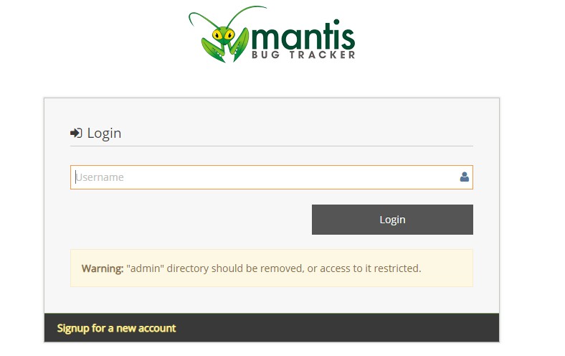
2) Landing Page:
The user will be able to see the summarized view of issues of the projects assigned to him here.
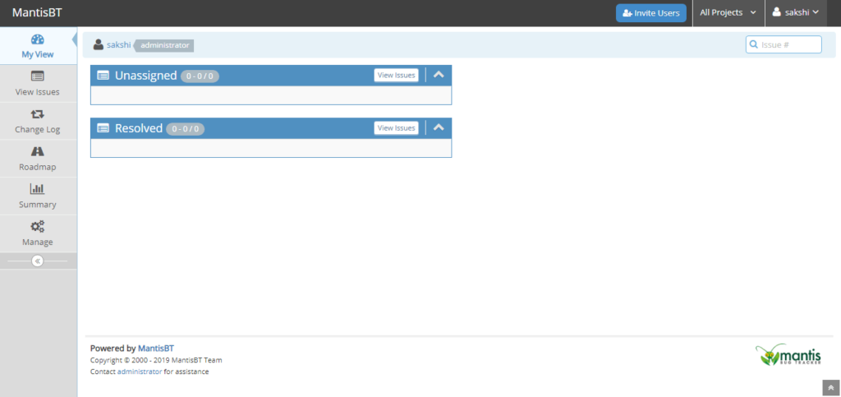
3) View Issues:
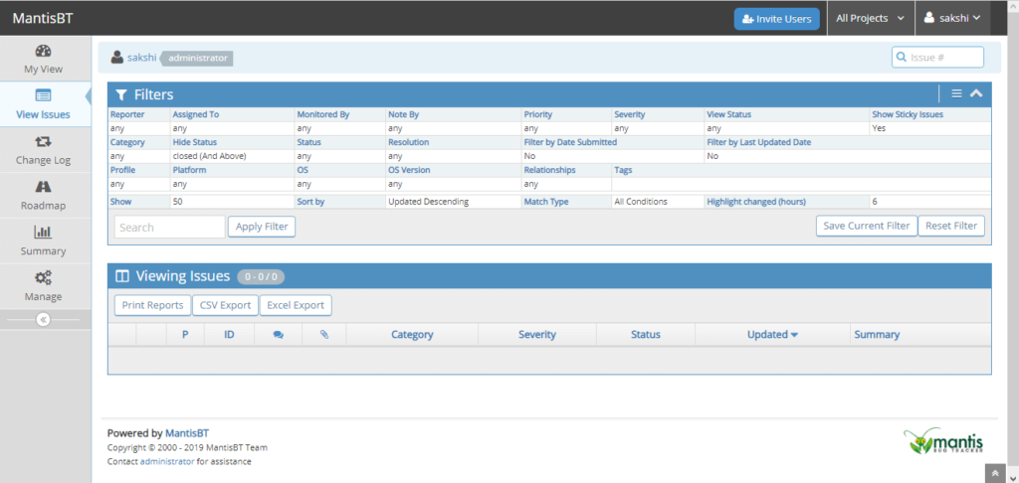
4) Summary:
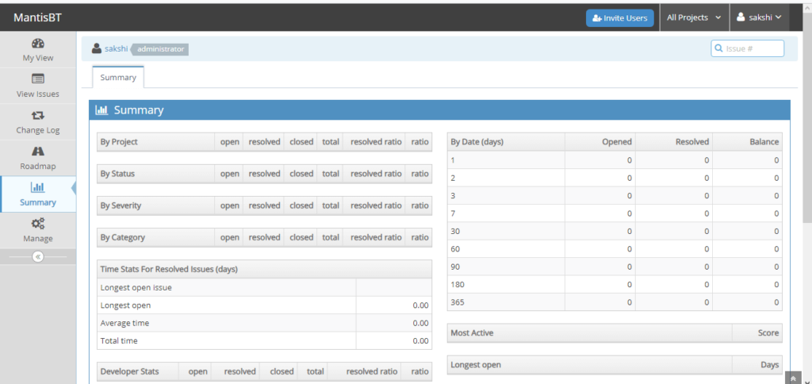
5) Manage:
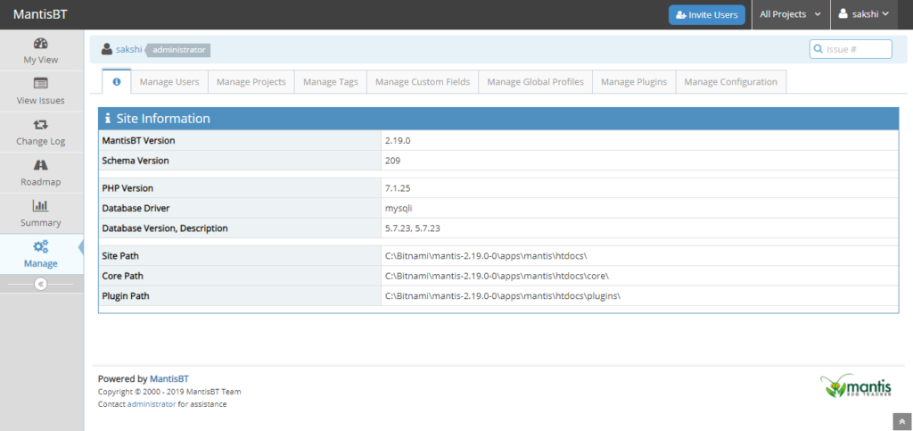
6) Create A New User Account:
When a user account is created the email address of the user, his real name is added. The user role is set here.
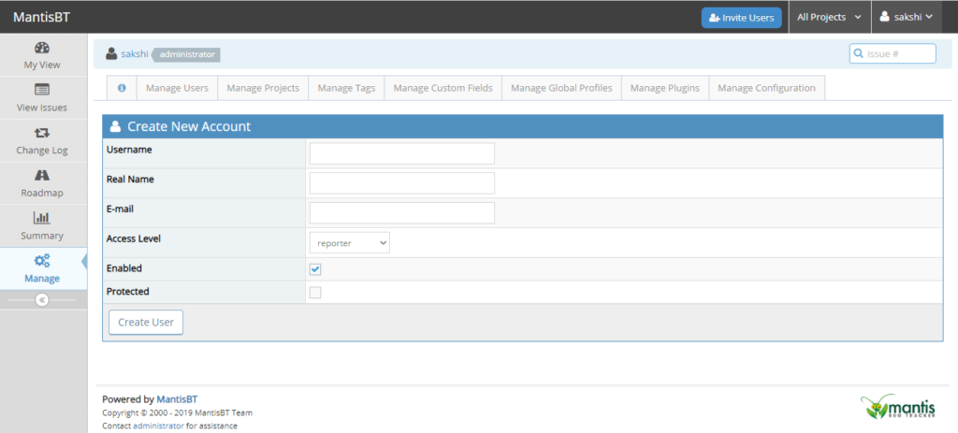
7) Create A New Project
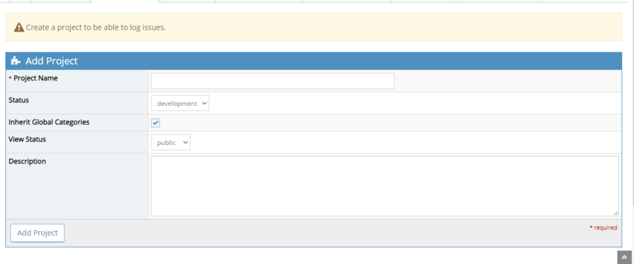
8) Create A New Custom Field
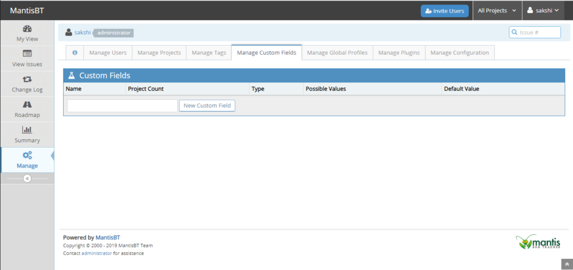
9) Manage User Roles Access Levels
The important part of user roles is set here. The features which are accessible to users can be changed from here by the admin.
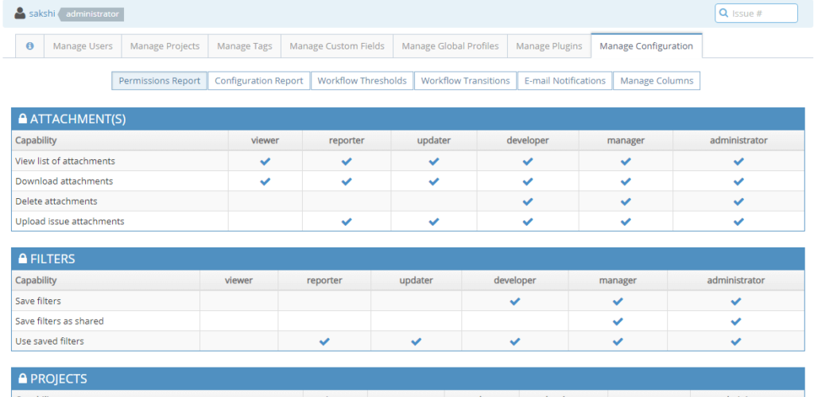
10) Email Notification Configuration
The admin is able to configure the email notifications here for which the email will be sent to the users at the project level.
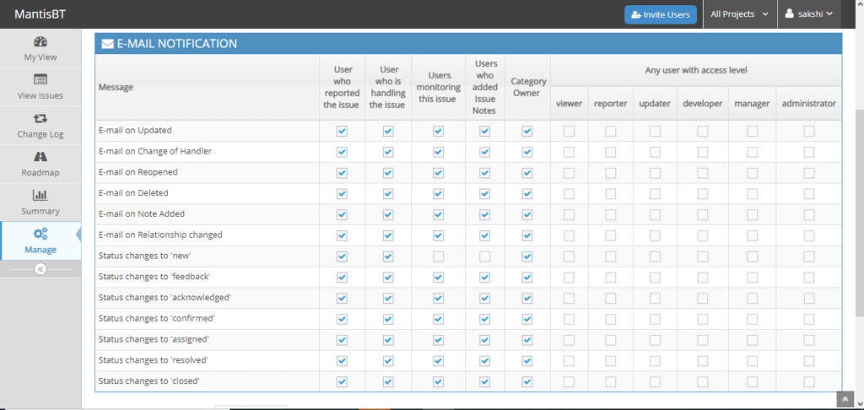
11) Workflow Configuration
The configuration of status and the user roles who can alter the status is set here.
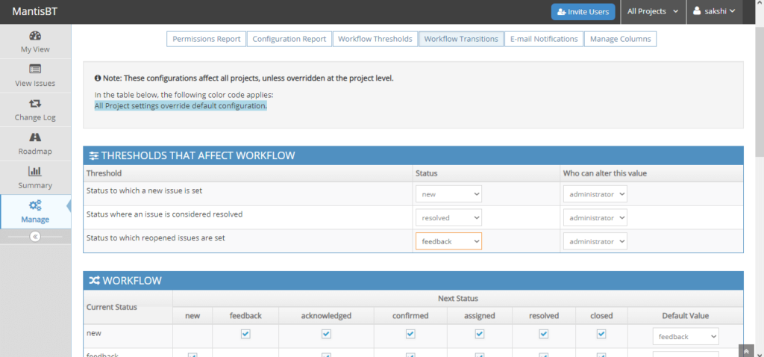

Conclusion
In this tutorial, we have discussed the basic and advanced features of MantisBT, its different versions MantisHub. The UI of MantisBT is quite familiar to users and easy to use. The admin login has all the accesses to add users, add projects, view summarized issue list, configure email notifications, set user roles access, configure the workflow, and add custom fields. The added users will be able to add issues, view issues and update issues only to the projects assigned to them and according to their user roles. MantisBT is an open source tool with customizable functionality and plug-in support for the extension of functions and integration with other software tools.

TestLink - Test Plan

Test planning, is the most important activity to ensure that there is initially a list of tasks and milestones in a baseline plan to track the progress of the project. It also defines the size of the test effort.
It is the main document often called as the master test plan or a project test plan and is usually developed during the early phase of the project.

Create a Test Plan
To create a test plan, you should have Create Test Plan Permission.
Following are the steps to create a test plan −
Step 1 − Go to Test Plan → Test Plan Management on the dashboard as shown in the following screenshot.
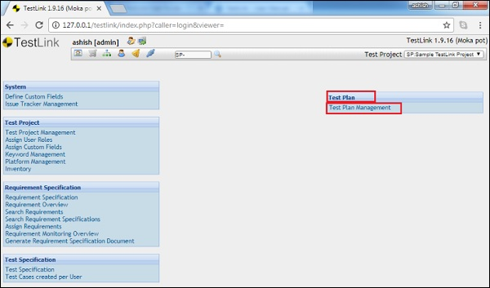
If any test plan is listed for the project, it displays the list of test plans. Otherwise, it displays a message to create a test plan to support the test execution functionality.
Step 2 − Click the Create button as shown in the following screenshot.
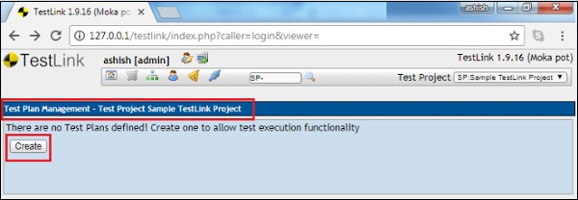
It displays the test plan create form.
Step 3 − Enter the following details in the form.
- Name − It should be the name of the test plan.
- Description − This field should contain the detailed information of a test plan. Generally, a test plan consists of the following information.
Sr.No. | Parameter & Description
1 | Test plan identifier  Unique identifying reference.
2 | Introduction  A brief introduction about the project and of the document.
3 | Test items  A test item is a software item that is the application under test.
4 | Features to be tested  A feature that needs to tested on the testware.
5 | Features not to be tested  Identify the features and the reasons for not including as part of testing.
6 | Approach  Details about the overall approach to testing.
7 | Item pass/fail criteria  Documented whether a software item has passed or failed its test.
8 | Test deliverables  Deliverables that are part of the testing process, such as test plans, test specifications and test summary reports.
9 | Testing tasks  All tasks for planning and executing the testing.
10 | Environmental needs  Defining the environmental requirements such as hardware, software, OS, network configurations, and tools required.
11 | Responsibilities  Lists the roles and responsibilities of the team members.
12 | Staffing and training needs  Captures the actual staffing requirements and any specific skills and training requirements.
13 | Schedule  States the important project delivery dates and key milestones.
14 | Risks and Mitigation  High-level project risks and assumptions as well as a mitigating plan for each identified risk.
15 | Approvals  Captures all approvers of the document, their titles and the sign-off date.
Testlink supports images, table, links, special characters, etc. to make content rich description.
There are 2 checkboxes as can be seen in the following screenshot.
- Active − It will activate the document after creation and you can utilize this document in test execution or any other activities as a reference.
- Public − It allows other users to use this document. It will be visible to other users as well who are linked with this project. If this checkbox is unchecked, only the person who has created can use and view this document.
Step 4 − Click the Create button present at the bottom of the form.
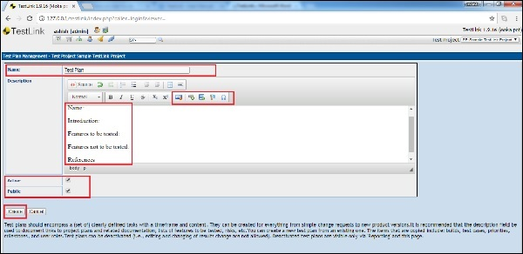
Once you click Create, you can see the added Test Plan along with a few icons at the extreme right of screen as seen below.
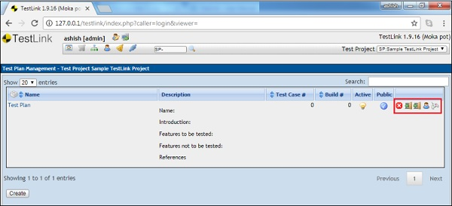
These icons are delete the test plan, export links to the test cases and platform, import links to the test cases and platform, Assign Role and test execution from left to right as displayed in below screenshot.

Edit a Test Plan
To edit a test plan, you should have Edit Permission.
Following are the steps to edit a test plan.
Step 1 − Click the Test Plan name to open the details. The name of the Test Plan is present in the first column and it is hyperlinked as shown in the following screenshot.
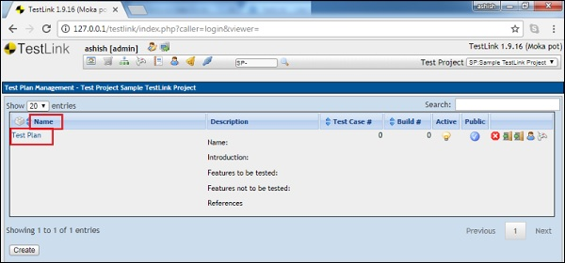
Step 2 − It opens the test plan details in edit mode. You can edit the name, description, and selection of Active and Public mode.
Step 3 − Attach a file in the test plan. This feature is available in the edit mode only. While creating the test plan, you can add images/tables into the description. However, attaching a file option is not available.
Step 4 − After updating the details, click Update to finish editing.
Following screenshot displays how to edit a test plan.
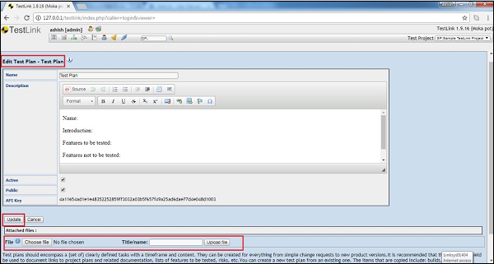

Delete a Test Plan
To delete a plan, you should have Delete Permission.
If a test plan is deleted, it deletes both the test plan and all of its corresponding data. Data includes test cases, results, etc.
Following are the steps to delete a build −
Step 1 − Go to the Test Plan Management → Test Plan from the dashboard.
Step 2 − Click the Delete icon corresponding to the row of the test plan that needs to be deleted as seen below.
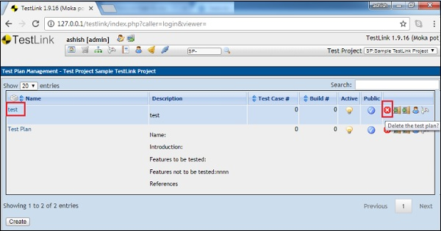
A pop-up will be displayed for a confirmation to delete.
Step 3 − Click Yes as shown below.
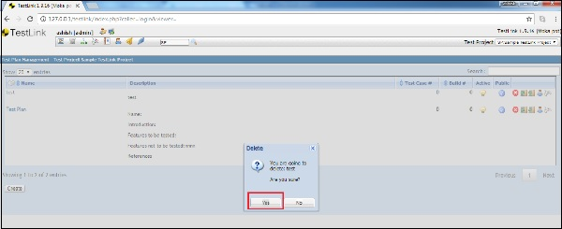
The page gets refreshed and the test plan will be delete

